Central Shenandoah Valley Master Gardeners Association
2021 Scholarship
Requirements, Application & Recommendation Forms (3)

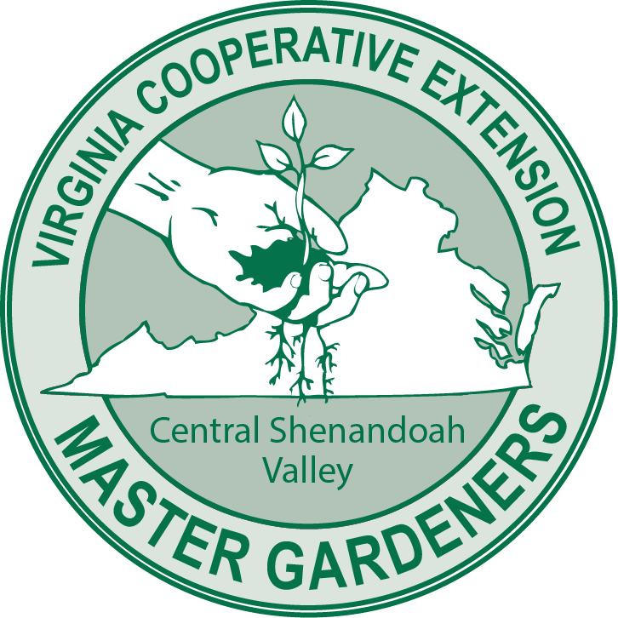

The mission of the Virginia Master Gardeners Association is to foster communication, education and fellowship among Virginia Cooperative Extension Master Gardener volunteers.

Central Shenandoah Valley Master Gardeners Association serves communities throughout Augusta County, Rockingham County, and the cities and towns therein.

The 2021 scholarship award is $1000. Two scholarships will be awarded. Notification of the award will be April 21, 2021. The award will be disbursed directly to the educational institution applicant will be attending.
Scholarship Eligibility: Graduating high school seniors in Augusta and Rockingham Counties, Virginia and cities within, with an expressed interest in pursuing post-secondary education focused on the world of plants. This could include, but not be limited to: horticulture, landscaping, forestry, agriculture, etc.
Scholarship Requirements: Completed Central Shenandoah Valley Master Gardeners Association Scholarship Application, high school transcripts, and three (3) personal references, at least one from a teacher and none from family members/guardians. Three recommendation forms are attached to this application.
Scholarship Application Available at: csvmga.org
Application and references must be postmarked by April 1, 2021. They should be sent to:
CSVMGA, Attn: Scholarship Committee
P.O. Box 2575
Harrisonburg, VA 22801

March 2020

Central Shenandoah Valley Master Gardeners Association
2021 Scholarship Application

Please type or print neatly:

First, Middle and Last Name:_______________________________________________________________

Date of Birth: _____/_____/_______ Email: ________________________ Phone:__________________

Home Address:__________________________________________________________________________

City: _________________________________________________ Zip Code: ________________________

High School Name:_______________________________________________________________________

Guidance Counselor: Name :_______________________________________ Ph#____________________

List interests, activities and awards. (Limit response to space provided below)

_____________________________________________________________________________________________

_____________________________________________________________________________________________

_____________________________________________________________________________________________

List the three people providing your references. (Recommendation forms are attached)

1._____________________________________________________________________________________

2._____________________________________________________________________________________

3._____________________________________________________________________________________

Write a personal statement, not to exceed one page, about your experiences with plants and your career goals. This may be included on the back of this page or on a separate sheet of paper.

I have personally prepared this application and believe it to be correct.

Signature of Applicant:_______________________________________ Date:________________________

January 2021

Recommendation Form
Central Shenandoah Valley Master Gardeners Association Scholarship
(Three Required)

Applicant’s Name _________________________________________________________________________

Your Name ________________________________________ Position/Title ___________________________

Address _________________________________________________________________________________

Phone __________________________________ Email _________________________________________

How long have you known the applicant? ______________________________________________________

Please attach a letter of reference indicating the unique factors that make the applicant especially worthy of scholarship support.

Signature ________________________________________________________ Date __________________

Please Mail to: CSVMGA, Attn: Scholarship Committee
P.O. Box 2575
Harrisonburg, VA 22801

References must be postmarked by April 1, 2021

January 2021

