**Central Shenandoah Valley Master Gardeners**

**and**

**Staunton Parks and Recreation**

Bug Hotel Workshop

Saturday, March 23, 2019

10 AM until Noon

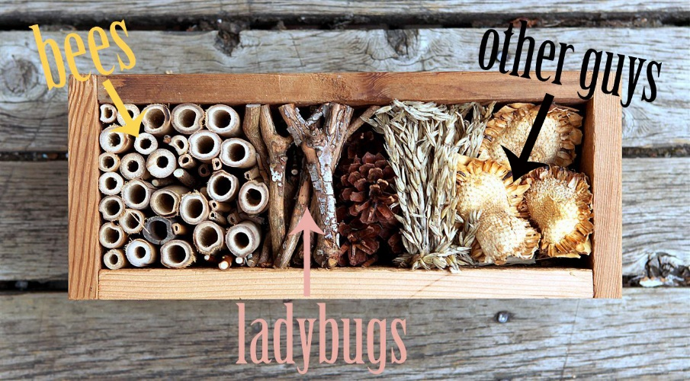 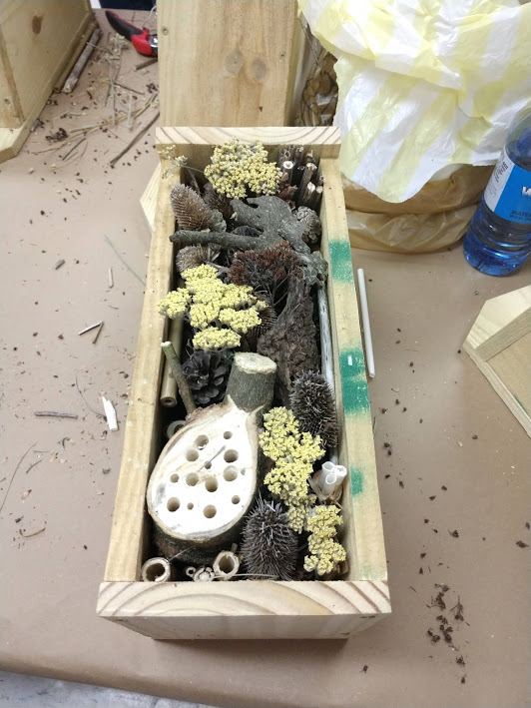

**Insects are an integral part of a successful garden. Some beneficial insects can actually help control and reduce the populations of detrimental insects, and many are responsible for the pollination of flowers, both ornamental and for food crops. By providing these insects with inviting homes, you can help promote their well being and contribute to increasing their numbers. When spring arrives, you’ll have all the**[**pollinators**](http://www.naturallivingideas.com/20-beautiful-flowers-attract-bees-garden/)**on hand that you need and many of your guests will devour the unwanted pests in your garden, getting the season off to a good start.**

**Here is your chance to come and build a Bug Hotel for your yard!! The Central Shenandoah Valley Master Gardeners are pairing with Staunton Parks and Recreation (see their recent ‘magazine’) to offer a workshop to save our pollinators.   There will be 30 minutes of education leaving plenty of time for us to show you how to make your own bug hotel to take home!  Go to the Activity Guide at**[**https://www.ci.staunton.va.us/Home/ShowDocument?id=5937**](https://www.ci.staunton.va.us/Home/ShowDocument?id=5937)**(the class is on page 19.)   Pages 25 and 26 will tell you how to sign up either online or mail-in.  Please join us!!**